NAME- HARSHIL DHARMENDRAKUMAR PATEL

ENROLLMENT- 2401030430027

Roll No-3CE-D-052

\*\*CAP FASHION BUY WEBSITE DESCRIPTION\*\*

\*\*Introduction:\*\*

The Cap Buy Website provides a user-friendly interface to browse, select, and purchase a variety of caps. The design focuses on simplicity and ease of navigation to enhance the shopping experience.

\*\*Features:\*\*

1. \*\*Homepage:\*\*

- The homepage prominently displays the product name "CAP" in a minimalistic style with vibrant green highlights.

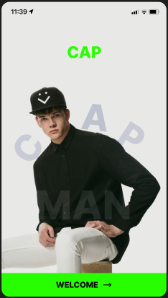

2. \*\*Product Display:\*\*

- Caps are showcased individually with a clear image, title (e.g., "Basic Baseball Cap 231"), and price (₹40,000).

- A carousel-style navigation allows users to view different angles of the product.

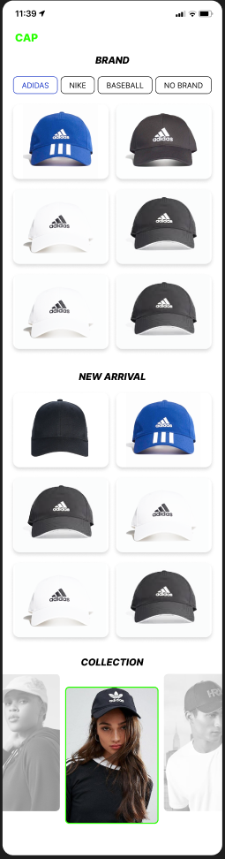

3. \*\*Brand Selection:\*\*

- Users can filter products by brand with options like "Adidas," "Nike," "Baseball," and "No Brand."

- The selected brand is highlighted for better visibility.

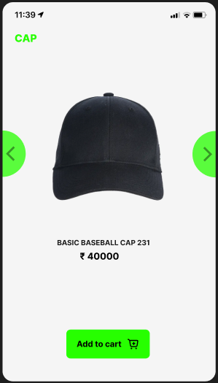

4. \*\*Collection Section:\*\*

- Highlights curated collections of caps with high-quality imagery of models wearing the products.

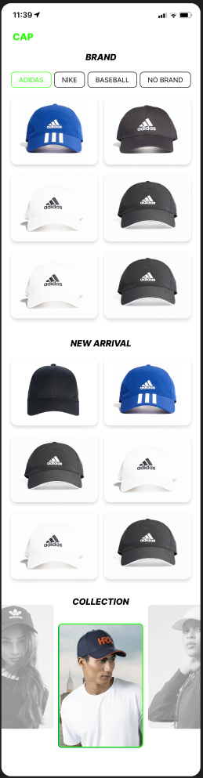

5. \*\*Interactive Buttons:\*\*

- Bright green buttons for actions like "Add to Cart" enhance usability and draw attention to call-to-actions.

\*\*User Interface Highlights:\*\*

- Clean and modern aesthetic.

- Mobile-friendly layout with intuitive touch navigation.

- Consistent color scheme (green and black).

- Seamless product exploration with swiping or tapping gestures.

\*\*Pricing and Details:\*\*

- Pricing is displayed prominently under the product title, ensuring transparency.

- Details like brand and collection categories provide easy filtering for user preferences.

\*\*Navigation:\*\*

- Green arrow buttons on either side of the product images allow easy switching between views.

- Scrollable lists for brand and collection exploration.

\*\*Conclusion:\*\*

The Cap Buy Website delivers an efficient and visually appealing platform for customers looking to explore and purchase high-quality caps. Its focus on user-centric design ensures a pleasant shopping experience.

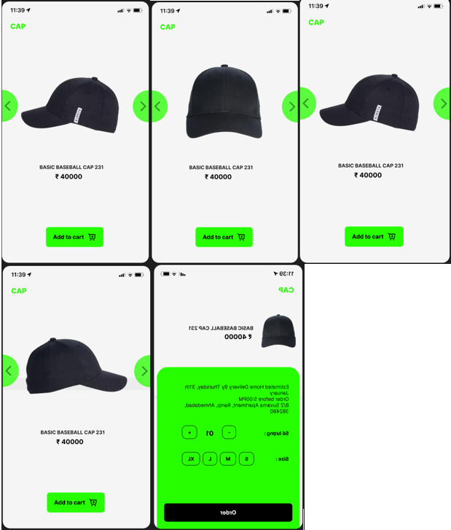

CREDIT-

ADIDAS

NIKE

HRX